**Week 1 Task 1**

**Python version**

**Question A**

For this question I used Python language with csv and datetime libraries.

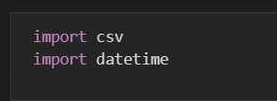

Figure 1

I designed a function to deal with the update flag and flag text operation. The first input is the path of the csv file that to be read, the second input is the path to the csv file output by python. If output csv file doesn’t exist, it will be created by python automatically.

All data of the input file is in reader. In for loop (line 8 of the Figure 2), I can get each row data. The first-row is the attribute and don’t need any operation to it. From second row of the data, I extract the first column which is [Date] attribute, and convert it to [date] type data of python. Then use weekday() function to get the exact date(Mon, Tues, Wed…). Finally, add the date to the flag and flag text attribute of each row, write it to a new csv file.

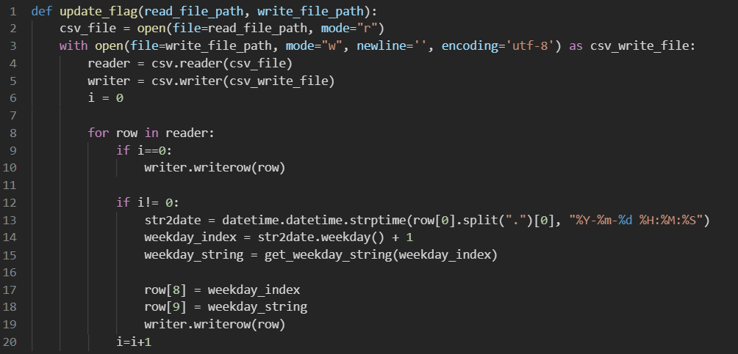

Figure 2

In line 15 of Figure 2, I create a function get_weekday_string() to covert 2 to Tuesday and 5 to Friday, as shown in Figure 3.

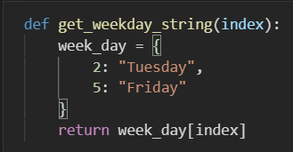

Figure 3

The screenshot of the result is shown below:

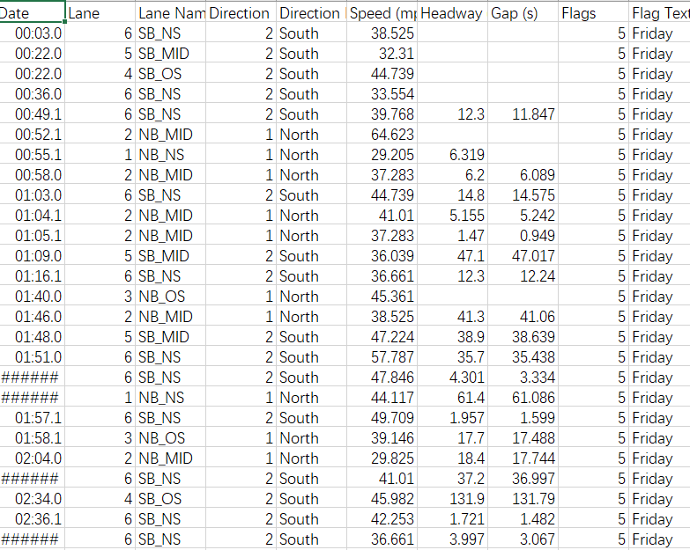

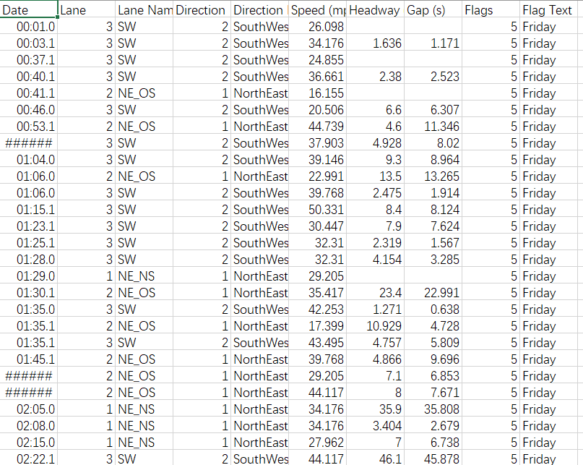

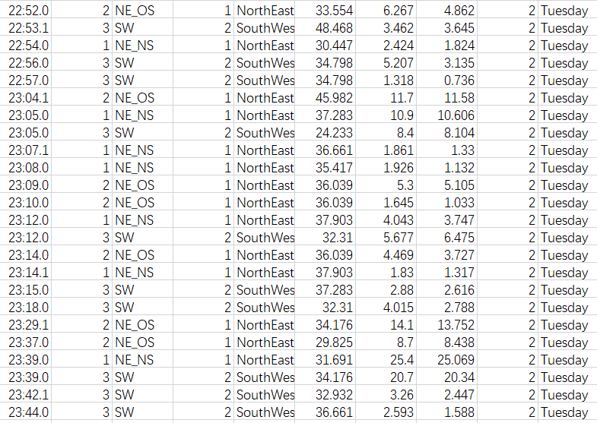

**Question B**

For this question, Python is also be used. Read the file and add 1 to variable Tue_volume when attribute [flag] is 2, add 1 to variable Fri_volume when arrtibute [flag] is 5.

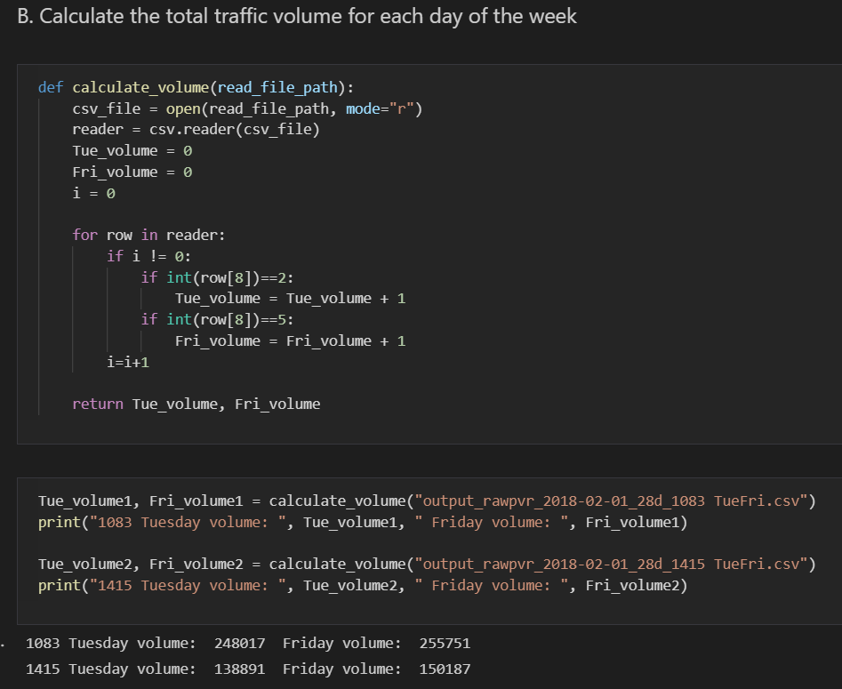

Result: Site 1083 has 248,017 traffic volume on Tuesday and 255,751 on Friday.

Site 1415 has 138,891 traffic volume on Tuesday and 150,187 on Friday.

In total: 386,908 on Tuesday; 405938 on Friday.

**Question C**

No data preparation step. All data is cleaned and within reasonable value range. Although there are some missing values in Headway and Gap(s), they don’t affect the result of question A and B.

**Excel version**

**Question A**

I used WEEKDAY() function and applied it to all remain [Flags] cells, and used IF() function and applied it to all remain [Flag Text] cells.

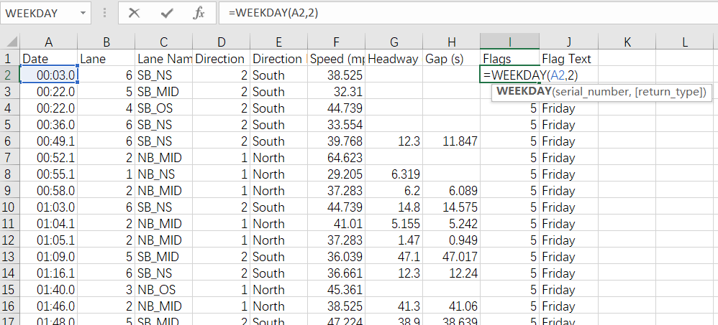

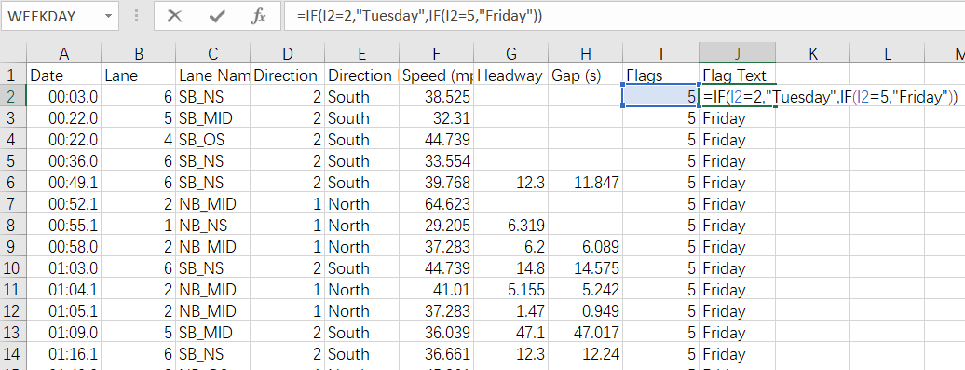

Question B

I use =COUNTIF(I2:I503769,"2") to calculate traffic volume on Tuesday and =COUNTIF(I2:I503769,"5") on Friday.

Result: Site 1083 has 248,017 traffic volume on Tuesday and 255,751 on Friday.

Site 1415 has 138,891 traffic volume on Tuesday and 150,187 on Friday.

In total: 386,908 on Tuesday; 405938 on Friday.